Video splicing processor PC client
Operation Manual
NVM
V 4.5

Catalog
1 Summarize 2
1.1 Summarize 3
1.2Topology 3
2 Installation 3
2.1 Installation environment 3
2.2 Installation step 3
3 Software Operate 5
3.1Login 5
3.2 Main interface and network 5
3.3 Signal management 7
3.4 Create Wall 9
3.5 Base map 10
3.6 LED 10
3.7 Operations 12
3.8 Plan 14
3.9 IP Card 15
3.10 Large screen switch 16
3.11 Configure Preview 17

1 Summarize

1.1 Summarize
Welcome to use video splicing processor PC client software manual. This manual details the installation and operation of the client software. Please read this manual before using the client. The current version of the PC client software is V4.5.

1.2Topology
Figure 1.1 below is the topology diagram of the splicing processor application:
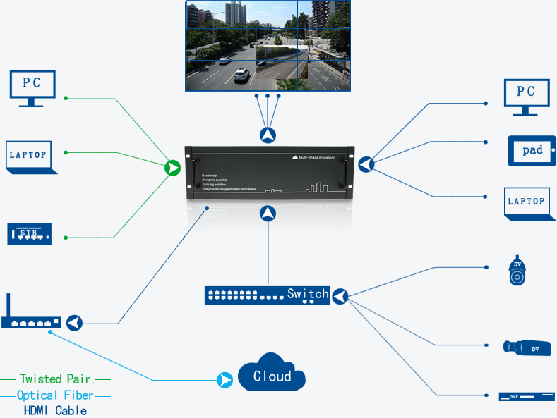
Figure1.1 Topological graph

2 Installation

2.1 Installation environment
Video integrated management platform PC client support in win7 and win10 system environment.

2.2 Installation step
- Double-click the setup installer and the interface shown in figure 2.1 appears. Click OK to enter the interface shown in figure 2.2 and click next:
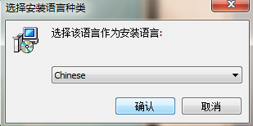
Figure2.1
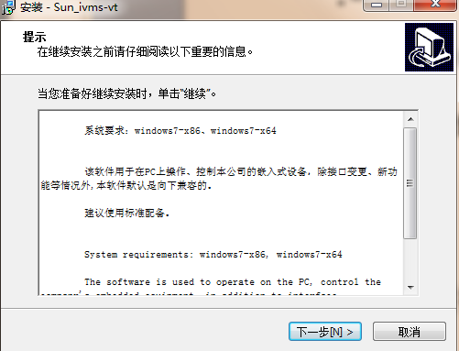
Figure2.2
- After selecting the software installation location, click "install" as shown in figure 2.3:
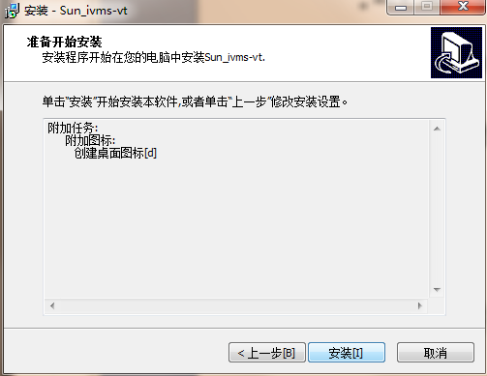
Figure2.3
- After successful installation of the software, as shown in figure 2.4, click next to figure 2.5, and then click "complete":
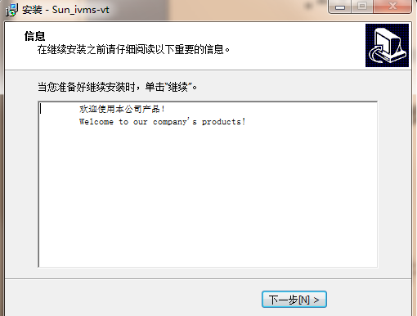
Figure2.4
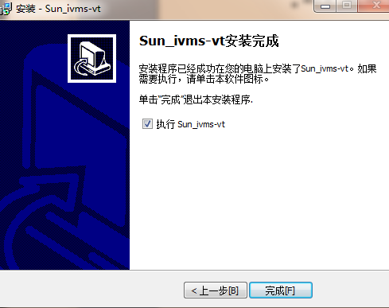
Figure2.5

3 Software Operate

3.1Login
Double-click the installed client and the login dialog box shown in figure 3.1 will pop up. The initial login user name and password are admin and 123456 respectively.Log in and enter the software.
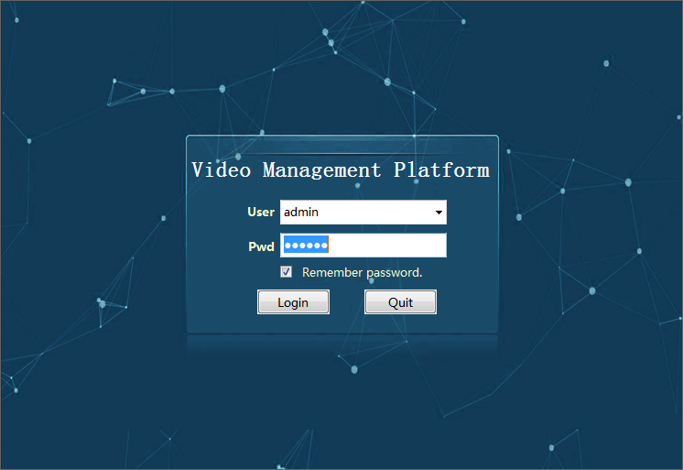
Figure3.1

3.2 Main interface and network
After logging in, enter the main interface "splicing control wall" (as shown in figure 3.4). The main interface displays the main menu buttons and curtain wall of the current splicing processor.The upper part of the main interface is the function button, and the lower left part shows the current signal source (the signal will be displayed in the main interface after the signal is searched in "signal management").In the middle is the current operable screen. When the mouse stays on the screen, the operation mode of the signal source will be prompted in the lower left corner of the interface.
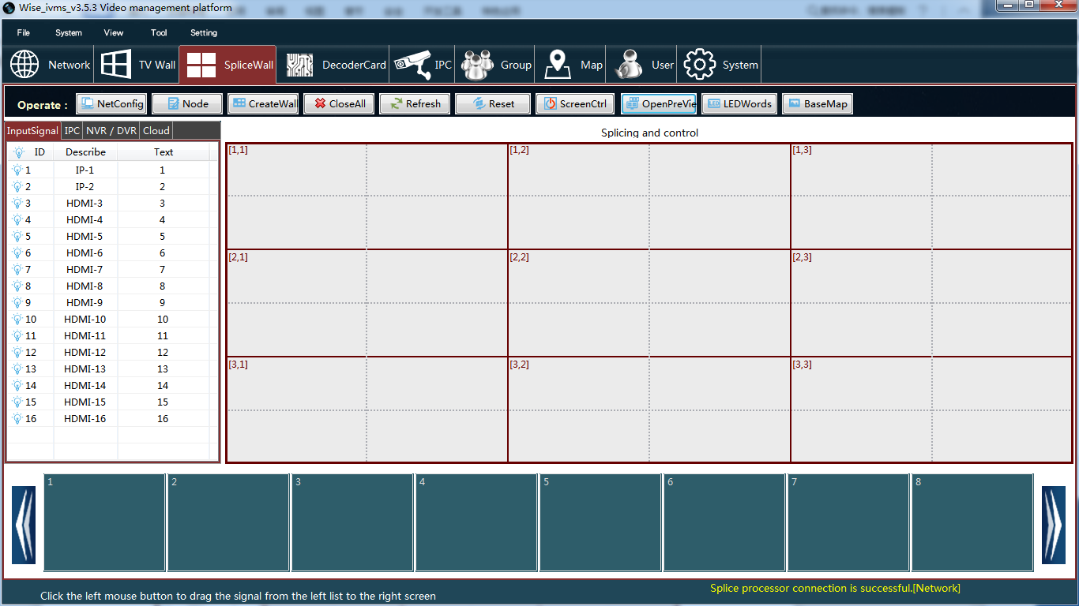
Figure3.4
If open the software for the first time, after entering the main interface system will automatically connect the IP for 192.168.1.20 splicing processor (factory default IP), if the connection is successful, can be directly to the back of the operation, if you don't succeed, then check the network, then click on "communication configuration" button to open the main interface to connect the network configuration of the interface in figure 3.5.
There are two modes of communication, network and serial port, and the default is "network" (figure 3.5).The mode of communication through the gateway is shown below:
- "Connection" : log in the default network configuration information for the first time as shown in figure 3.5. Click the "connection" button. If the bottom of the screen prompts "connection success of splicing processor", you can start the operation., then check whether the IP configuration information is wrong or the site network is not connected and other reasons.
- "Modification" : please modify the network configuration information if you are sure that the current IP connection is successful.After modifying the information, click "modify" and the prompt "modify successfully!Please reconnect, and then click connect.Note the changes to the subnet mask and gateway as you modify the IP.
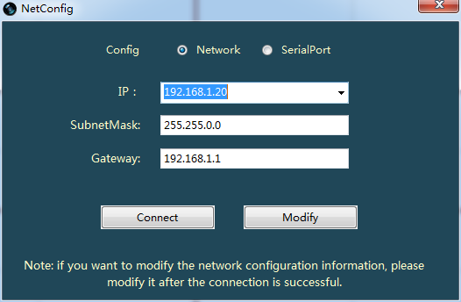
Figure3.5
The communication mode through the serial port is shown in figure 3.5.1. Connect the serial port line, select the correct port number and baud rate after opening the interface, and click "connect" to prompt "connection successful".The disconnect button disconnects the currently connected port.
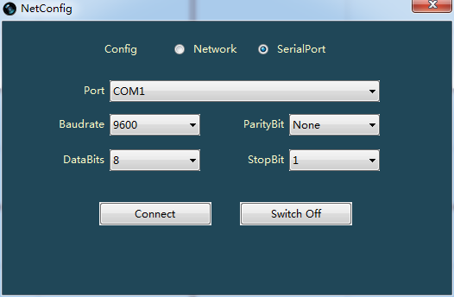
Figure3.5.1

3.3 Signal management
After the network connection is successful, enter the "signal management" interface, as shown in figure 3.6, which is mainly used to search and display input signals and output signals.The searched input signal will be displayed synchronously in the list on the left side of the main interface in figure 3.4.
Note: if the number of input and output CARDS changes, the splicing processor is connected and the signal is searched before other operations.
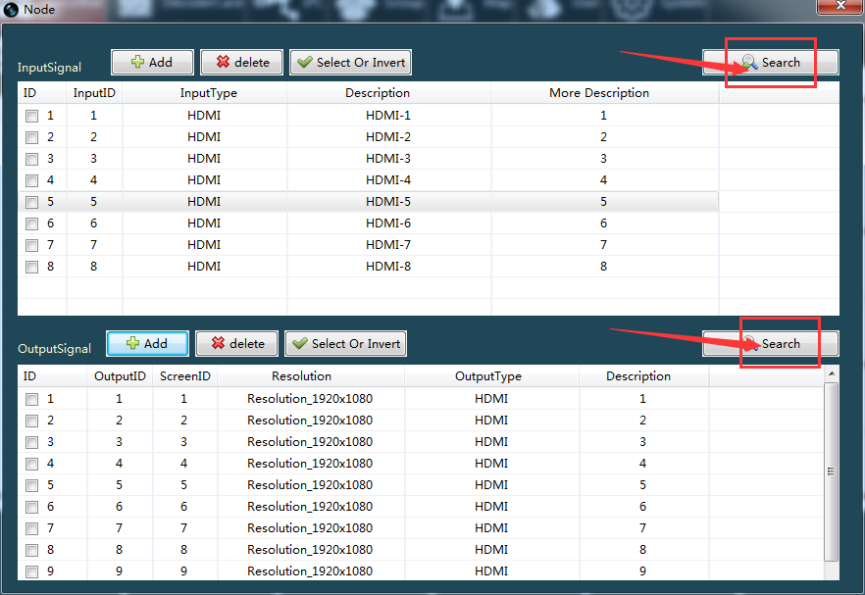
Figure3.6
A．Input Signal:
- Search: click the "search" button in the upper right corner of figure 3.6, and the corresponding input signal will be listed if the input card is detected.After the search, check whether the input number is continuous, which means that all input CARDS have been searched.As shown in figure 3.6, 16 signal sources are represented by four input cards.
- Modification information: double-click the line where a signal source is located and the interface as shown in figure 3.7 pops up to modify the type of the signal and overlay text.(double-click the list on the left side of the main interface in figure 3.4 to modify it)
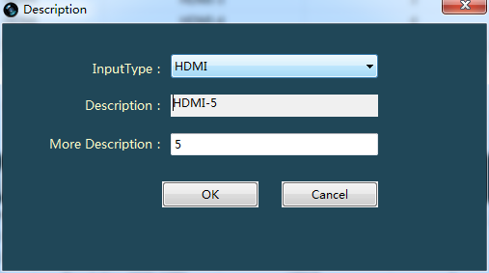
Figure3.7
- Manual addition: if no input signal is found under normal network conditions, the input signal can be added by "manual addition".As shown below, fill in the number of input cards and "confirm".One input card represents four input signals)
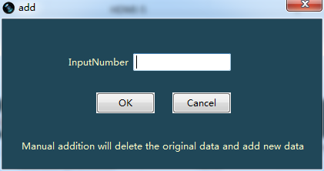
Figure3.6.1
- Delete: this button deletes the input signal checked in the current list.
B．Output Signal:
- Search: click the "search" button of the output signal in figure 3.6, and the output card detected will list the corresponding output signal.After the search, check whether the output number is continuous. If not, the output card is not found.
- Manual addition: if no output signal is found under normal network conditions, the mode of "manual addition" can be used.As shown below, fill in the number of output cards, and select "4 output" or "2 output" in the drop-down box on the right, and then "OK".
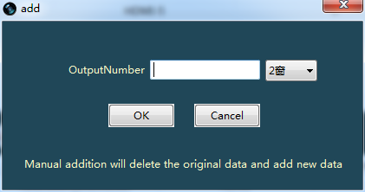
Figure3.6.2
- Delete: this button deletes the checked output signal in the current list.

3.4 Create Wall
After the output signal is searched in signal management, the appropriate curtain wall is created based on the number of output signals. If there are 4 output signals, create 2*2 curtain wall and edit the screen name. Click "OK" to create successfully, as shown in figure 3.8 below. Note the continuity of the output number before "OK")
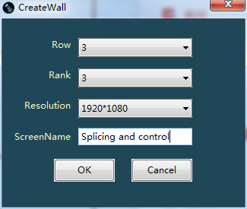
Figure3.8

3.5 Base map
Base map means that when there is no signal input in the connected large screen, the custom picture can be used as the background of the curtain wall, which means that the blue screen will no longer be displayed. First click the "open file" button in figure 3.9 to select an image, and then click the "download" button.(the "open base map" button can open the base map that was downloaded last time. If the base map has not been downloaded before, the opening is invalid.
- "All screens are the same base map": check this button, and then each screen will display the same base map after downloading. The default is not checked, at this time the end of the download for Mosaic base map.
- "Start position" : select the position of the column and column where the image starts to download, and the default is 1*1 (i.e., row 1, column 1);
- "Size": indicates the line size of the downloaded picture, which is consistent with the line size of the current curtain wall by default. For example, if the curtain wall size created in figure 3.8 is 2*2, it is also 2*2.
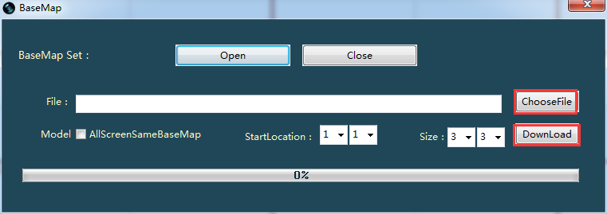
Figure3.9

3.6 LED
This function can display LED welcome words subtitles at the top of the screen. The operation interface is shown in figure 3.10. The specific steps are as follows:
- Type the subtitle to display in the content box.
- Click "add" button to add the subtitle to the LED list (you can set the font color, background color, transparency, text size and position, etc., and then add.)
- Select an LED in the LED list and click "download content". When the progress bar is 100% completed, LED subtitles will be displayed on the screen.
- Modification: select an LED in the LED drop-down list, and the LED will be displayed in the "content" box. Click the "modify" button after modification.
- Delete: select the LED to be deleted from the LED drop-down list and directly click "delete".
- Font color/background color: optional "red, black, blue, yellow, green". Cannot choose the same color)
- Text size: LED subtitle size, with a 0-10 selection range, the larger the number means the larger the text.
- Transparency: there are three options: 100%transparent, 50%translucent, 0%translucent.
- Scroll speed: LED subtitle scroll speed, 0-10 range of choice, the larger the number, the faster the speed, 0 means stop. Select and then click the "set time" button to change the speed.
- Text position: center alignment is selected by default. If the scrolling time is set to 0, that is, when the subtitle does not scroll, select any text position and click the "Download" button to see the effect on the screen.
- Open LED: can open the previous downloaded LED, if not previously downloaded LED, open invalid.
- Close LED: Close the currently opened LED.
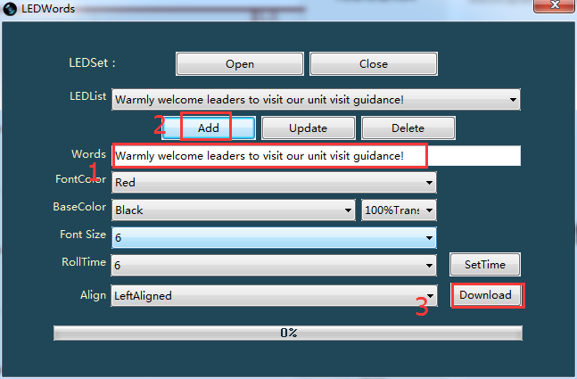
Figure3.10

3.7 Operations
- Call in signal source: drag the signal source below the screen directly into the screen grid with the left mouse button, or drag the signal source to the left of the main interface directly into the screen grid, as indicated by the red arrow in figure 3.11.
Note: 2 output control CARDS can input 4 signal sources per screen, 4 output control CARDS can input 2 signal sources per screen. If the number of Windows is exceeded, the prompt will be given in the upper left corner of PC.
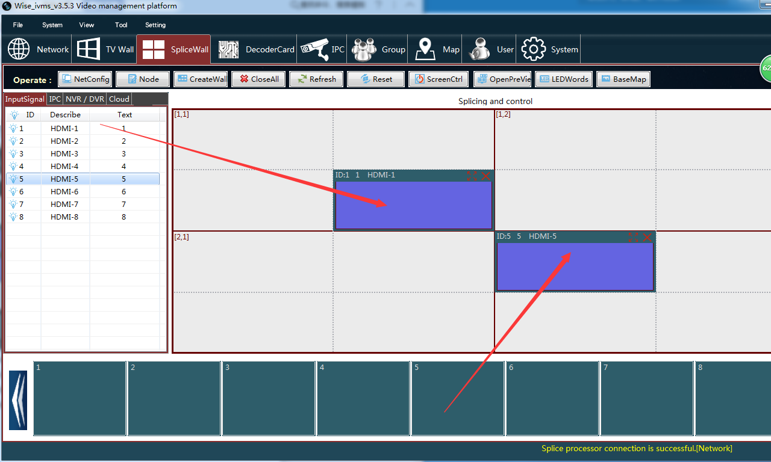
Figure3.11
- Move signal source: move the mouse pointer to the signal source, and drag the mouse to move any position of the window. Figure 3.12 is the result of moving the signal source in figure 3.11 to the lower right corner:
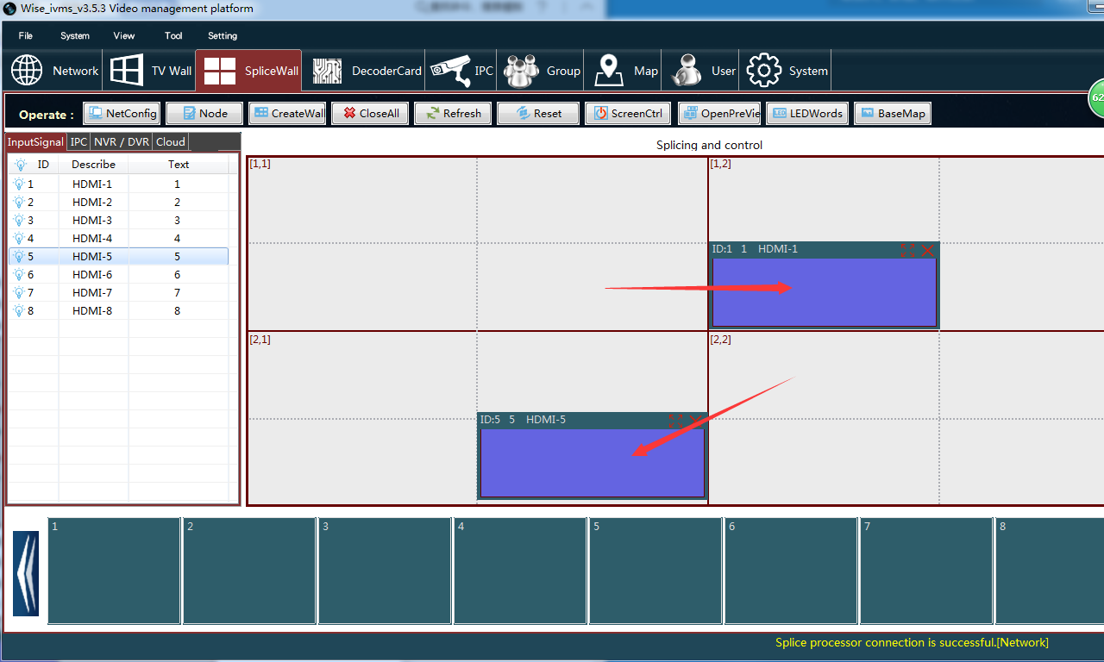
Figure3.12
- Resize window: place the mouse pointer on the right edge, bottom edge or bottom right corner of the signal source window, and drag the window edge to change the window size, as shown by the red arrow in figure 3.13.
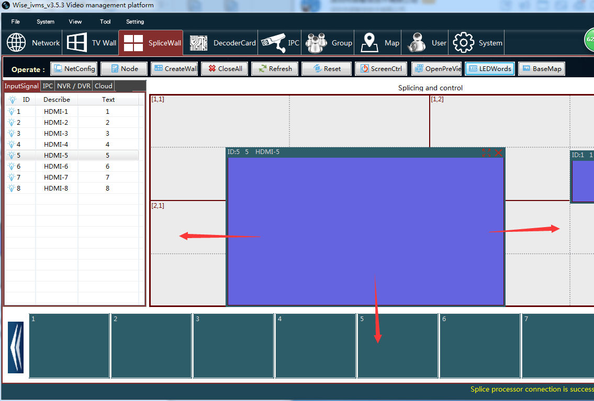
Figure3.13
- Fixed to grid: this function is under the control option on the left side of the main interface, as shown in figure 3.14.When ticked, the window size will be arbitrarily moved or changed, and the signal source will be fixed in the grid.
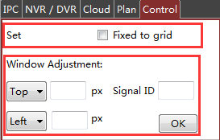
Figure3.14
- Turn off signal source: the button in the upper right corner of the signal source is turned off, as shown in figure 3.15.
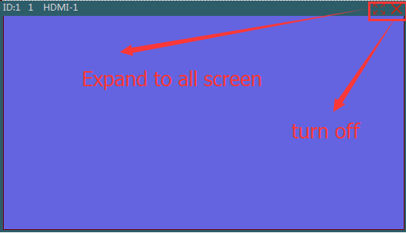
Figure3.15
- Window maximization: as shown in the figure above, the window maximization button is the one to the left of the close button.
- Close all: Figure 3.4 "Close all" button in the main interface can close all signal sources on the current screen with one click。

3.8 Plan
- Add plan: after logging into the video source, click the "add plan" button on the left side of the main interface, as shown in FIG. 3.18. Edit the plan name in the pop-up interface, as shown in FIG. 3.19.The saved plan can be viewed in the plan directory in figure 3.18.
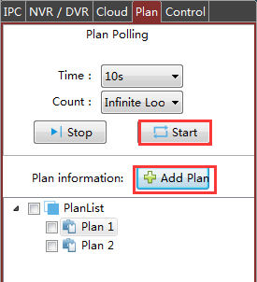
Figure3.18
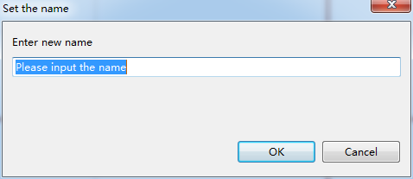
Figure3.19
- Call in: click the right mouse button on the saved plan name to display the menu as shown in figure 3.20, and then click "Call in"。
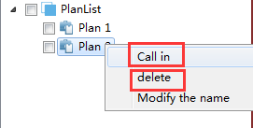
Figure3.20
- Delete: click the right mouse button on the name of the plan to see the menu as shown in figure 3.20, and directly click the "delete" button.
- Modify plan name: click the right mouse button on the plan name to display the menu as shown in figure 3.20, click "modify plan name", and then modify the name in the pop-up interface.
- Start cycle: as shown in figure 3.18, check the plan and click the "start cycle" button. The selected plan will be synchronized with the cycle on the PC client and the screen. The number of rounds is unlimited by default, and the cycle time is 10 seconds by default.
- Stop cycle: click the button to stop the current cycle.

3.9 IP Card
Configure the network information and IPC of IP card in "business card" and "monitoring point", change the input card type corresponding to IP card from "HDMI input card" to "IP input card" in the signal management of "splicing control wall", and then call the signal source of IP card into the curtain wall. As shown in figure 3.21, the signal source of the first IP card is dragged into the curtain wall grid.(refer to 3.7 window opening operation).
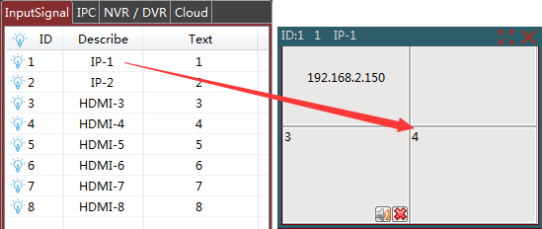
Figure3.21
- Call in IPC：Drag the IPC in the IPC list on the left side of the interface into the channel of the signal source of the IP card with the window opened on the right side.
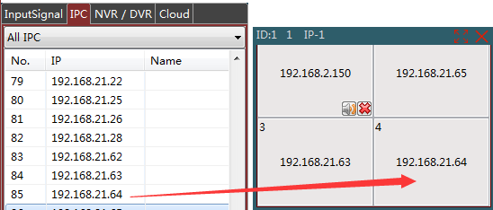
Figure3.22
- split screen：Click the right mouse button on the open window IP card signal source to pop up the split screen menu in the figure below to control the split screen.
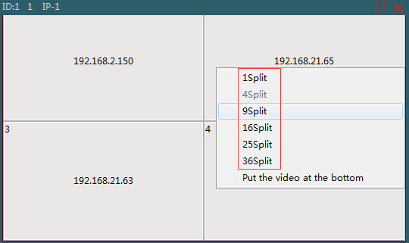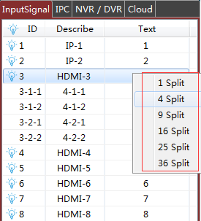
Figure3.23 Figure3.24
- Detached source：Right click on the input signal shown on the left side of the main interface to pop up the dispersion menu as shown in the figure below. After that, each line can be called into the curtain wall as a separate signal source. As shown in the figure below, the no. 2 signal source is broken into a state of "4 screens". Note: after closing the PC client and re-opening it, the signal source will be restored to unshattered state)

3.10 Large screen switch
- Add instruction: double-click in the boot instruction and shutdown instruction list and enter the instruction. Click button "save" to view the instruction under the "screen name" list. As shown in figure 3.25.
- Serial port setting: open "serial port setting" as shown in figure 3.26, and "OK" after matching the correct port number. Before calling the instruction, make sure the serial port is connected successfully.
- Turn on: select a screen name in the list of screen names and click "On".
- Turn off: under the list of screen names, select the screen name at startup and click "Off".
- View instruction: select a screen’s name information under the screen name list, and click "view instruction" to view. Double-click on the command line to modify the instruction and save it again.
- Delete: select a screen name under the screen name list and click "delete".
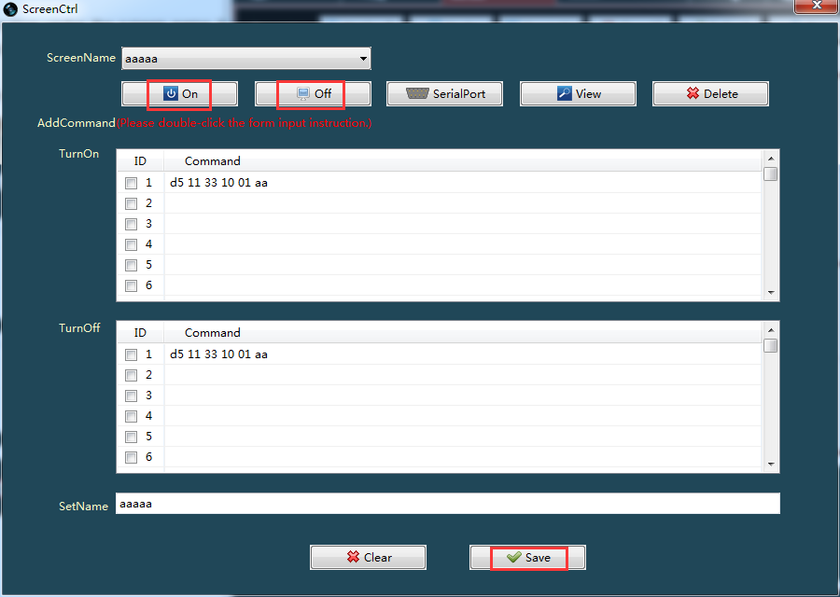
Figure3.25
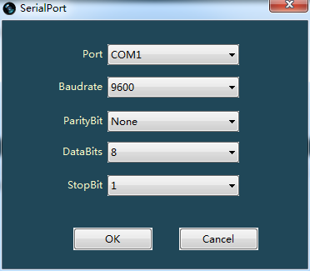
Figure3.26

3.11 Configure Preview
Connect the splicing processor in the "communication configuration" and search all board carsd in the "signal management". Two echo card IP information has been default in the left side of the main interface under the "control", as shown in figure 3.27.There is the "open echo" function button at the top of the main interface. Click it to open the echo at the bottom of the interface and view the 8-way preview image at one time.
- Open Preview：Click the "Open Preview" button on the main interface to open the echo, as shown in figure 3.29. Switch buttons on both sides of the lower side to view the preview images of other signal sources。
- Close Preview：Click the "Close Preview" button again to close the Preview。
Modify IP: double-click the left mouse button to echo the line where the IP is, and the modified IP interface pops up for modification, as shown in figure 3.28.
Note: when the echo is opened and closed, the screen wall will be reconfigured, so all the currently opened Windows will be emptied. If you do not want to empty it, you can save a plan and call it again after the preview is opened)
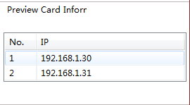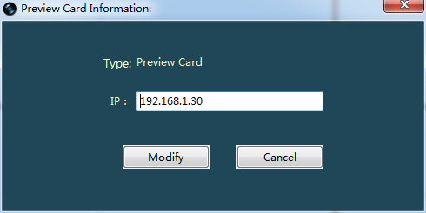
Figure3.27 Figure3.28
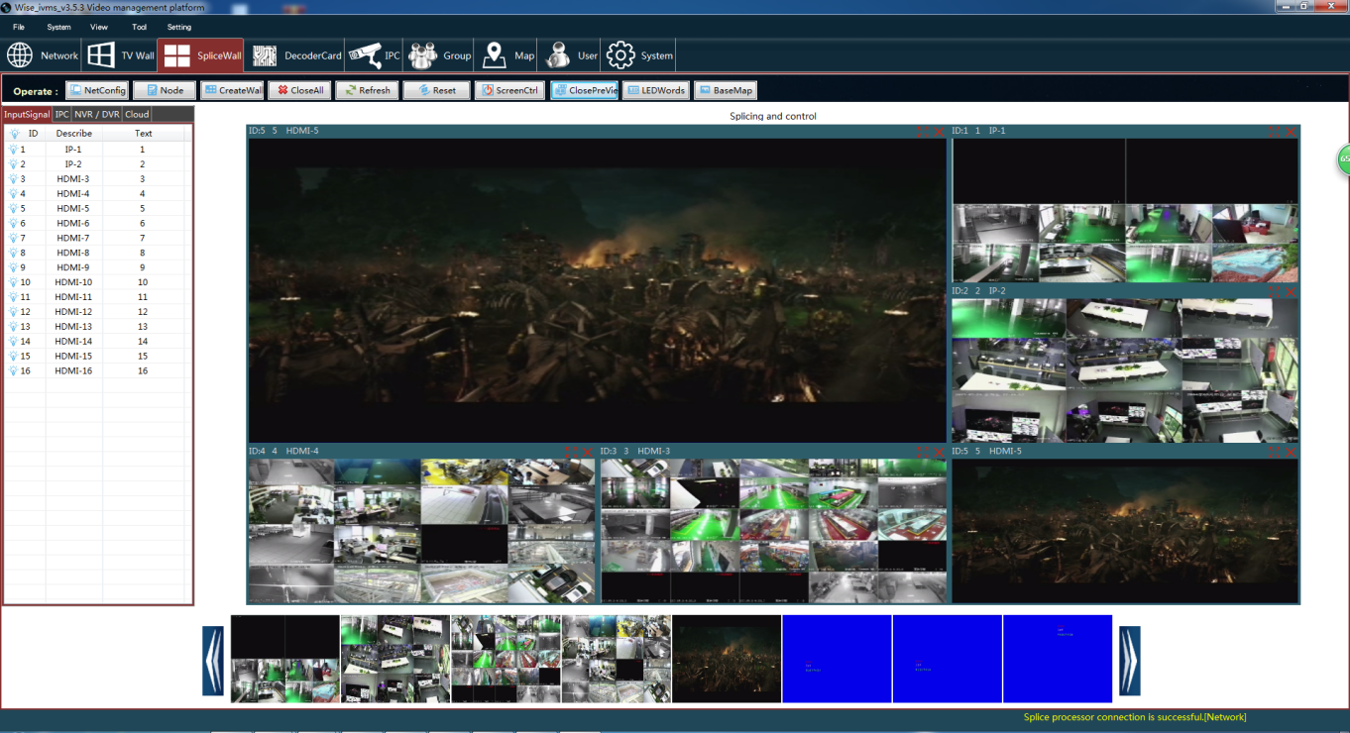
Figure3.29

